Check Processing PA (Payment Authorization)
The Check Processing - PA tab is used to post a transaction for a computer check or post a district check for a payment authorization. When posting a transaction or district check by PA, the system automatically updates the general ledger expenditure and contra accounts. Additional PA updates are not necessary when paying a PA since there are no encumbrances.

Duplicate PA numbers can be used as long as the vendors are not the same.

Fifteen transactions can be placed on a single vendor check before the transactions flow over to the next check. The totals are displayed on the last check to that vendor. All previous checks are then voided by the system.

___ 1 Finance>Maintenance>Postings>Check Processing – PA…..VERIFY THE ACCOUNTING PERIOD YOU ARE IN!
To add a new PA, click Add PA.

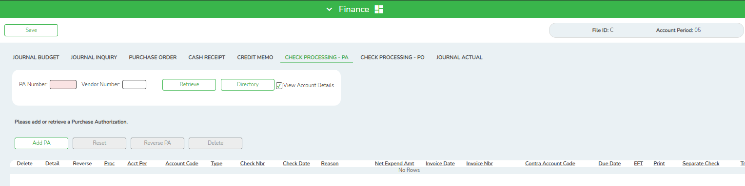

- If Use Automatic PA Number Assignment is selected on the Tables > District Finance Options > Finance Options tab, the PA Nbr field displays AUTO. Once the line is saved, the system automatically replaces AUTO with the next available PA number.
- If Use Automatic PA Number Assignment is not selected on the Tables > District Finance Options > Finance Options tab, the PA Nbr field is editable and the user must enter a PA number. If the PA number is numeric, leading zeros are not required.

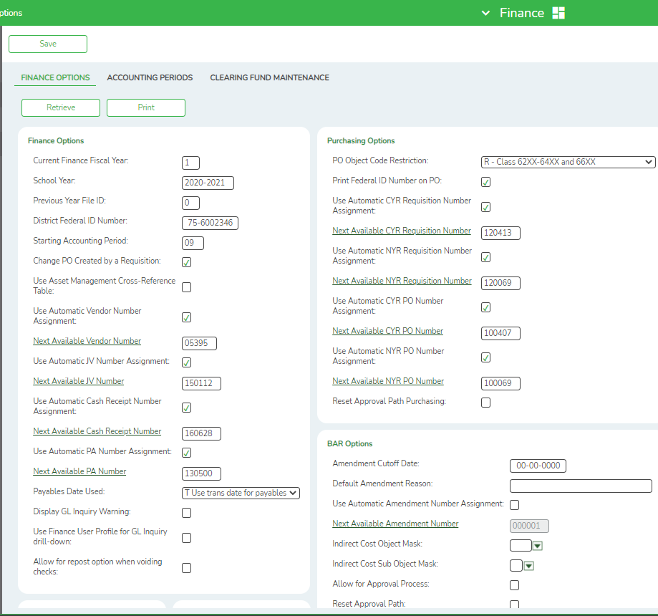

___ 2 In the Sort Key/Vendor Name field, type a valid vendor name. The drop-down list displays the sort key, vendor name, and vendor address. Only active vendor names are displayed. The system populates the Vendor Nbr field with the vendor number.
Note: The system displays an inactive vendor if the vendor has check transactions that have not been printed or a purchase order that still has a balance. Once all check transactions have been paid and all purchase order balances are zero, an inactive vendor will not display in the drop-down list.

___ 3 To add a row, click +Add, or press ALT+1.
Note: When using ALT+1 to add a new row to the grid, you must use the 1 key on the keyboard, not the 1 key on the numeric keypad.

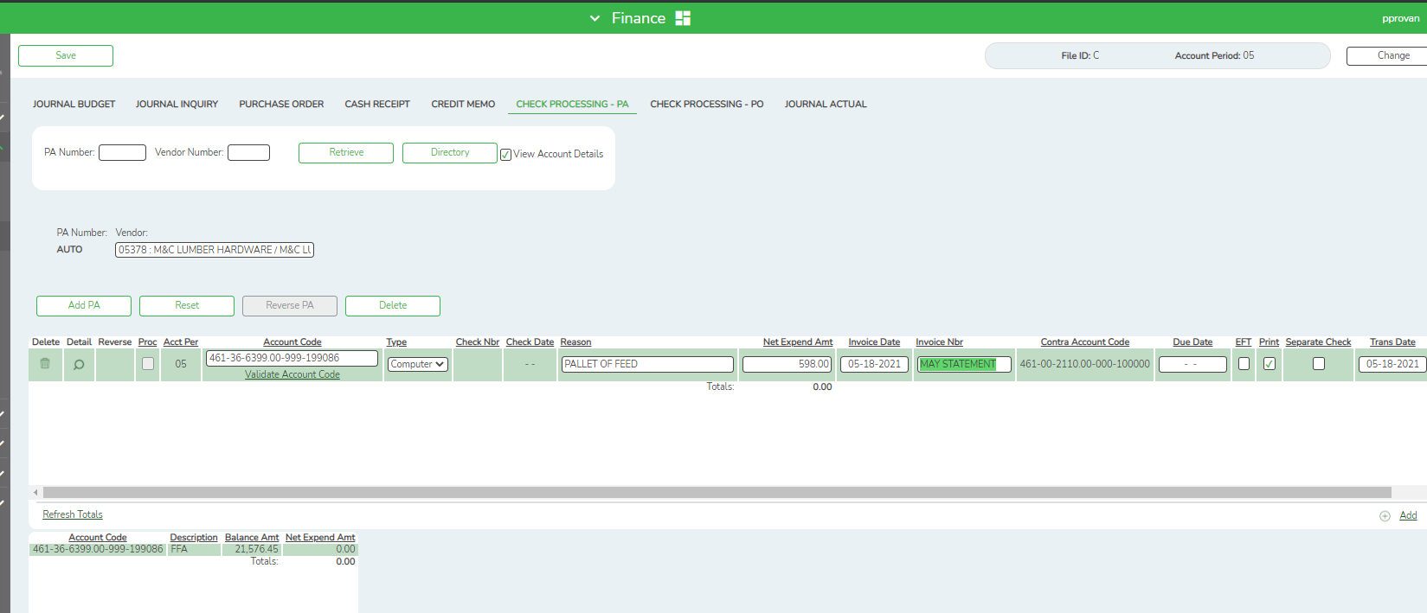

___ 4 In the Account Code field, enter the account code desired. The same account code may be used multiple times. By typing in the account code you will see a list of account numbers to choose from. You are also able to view a list of account code components by placing the cursor in one of the account code component fields, and then click Lookup or press F2.
- A list of available account code components is displayed.
- Select the account code component you wish to select. Otherwise, click Cancel to return to the Check Processing - PA page.

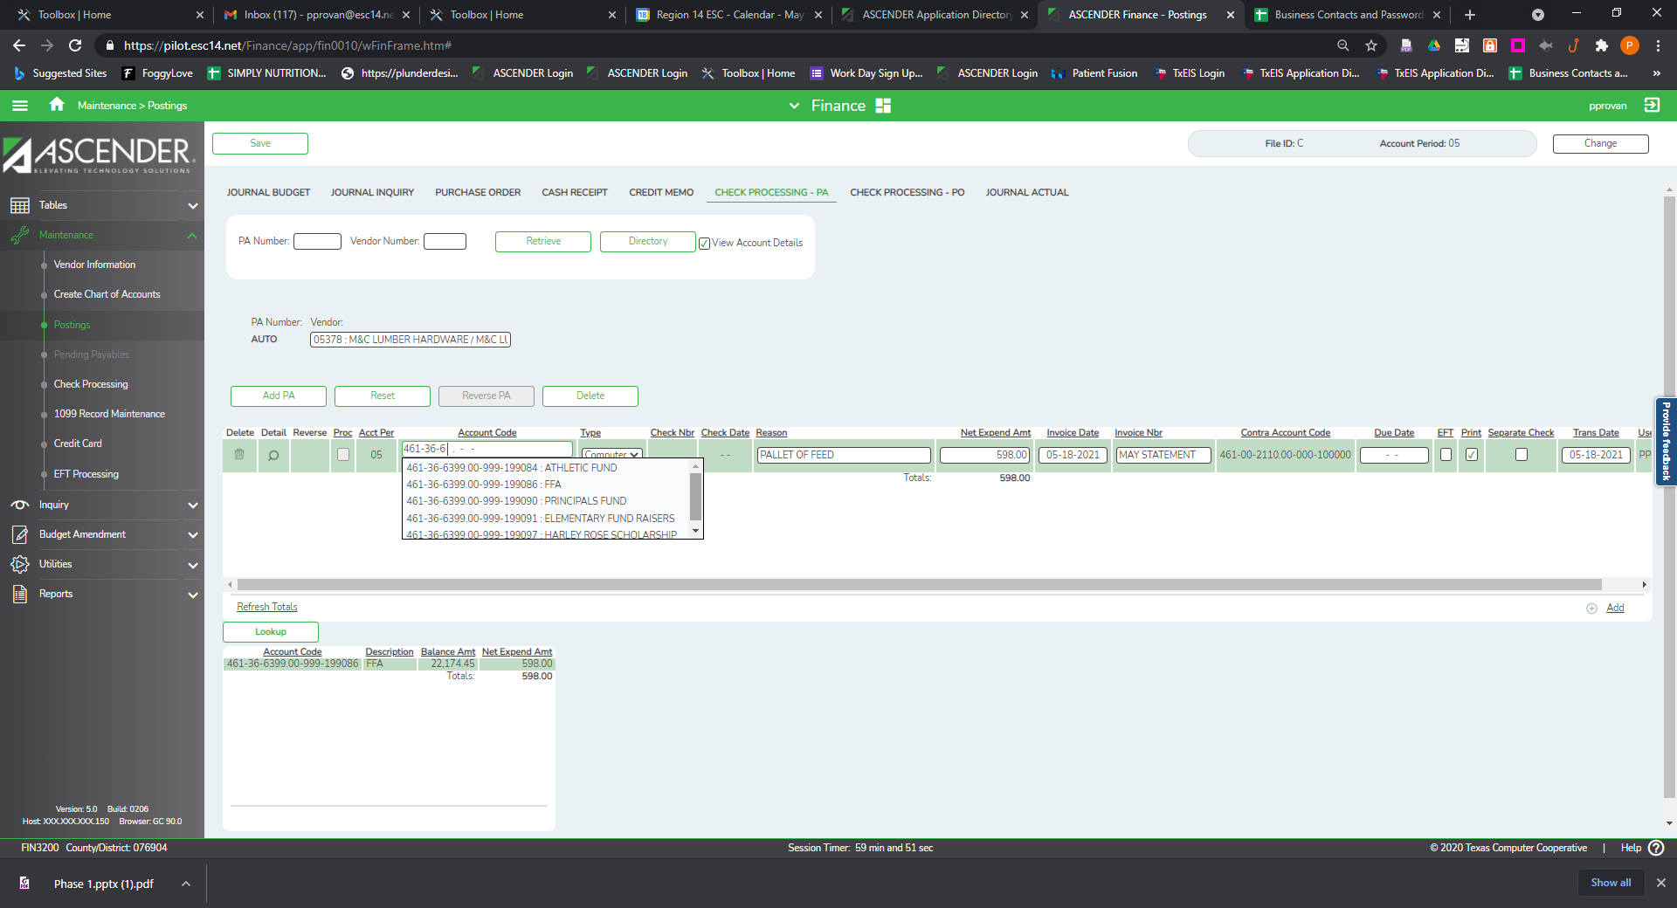
or
Lookup

___ 5 In the Type field, click the dropdown to select either computer or district type check. The following table shows which fields are required depending on the selection in the Type field.

Field to Fill In | Computer | District
Check Nbr | No | Yes
Check Date | No | Yes
Reason | No | No
Invoice Date | No | No
Invoice Nbr | No | No
Contra Account Code | No | Yes
Due Date | No | No
Print | Yes | No
Separate Check | No | No
Trans Date | Yes | Yes

___ 6 The Check Nbr field is enabled only after the user selects District as the check type to be issued. This is a user-defined field and can be a maximum of six digits. The field does not have to be filled, so the user can enter one or more digits.
Notes:
- The system validates the check numbers for district checks and displays a message if the user enters a duplicate check number.
- After a deferred check is printed, the check number description will display "PAYABL" in the expenditure account. The numerical check number is displayed in the accounts payable account for the accounting period in which the check was printed.

___ 7 The Check Date field is enabled only after the user selects District as the check type to be issued. Type the date the district check is issued.

___ 8 In the Reason field, type a user-defined reason for the transaction. The field can be a maximum of 30 characters.

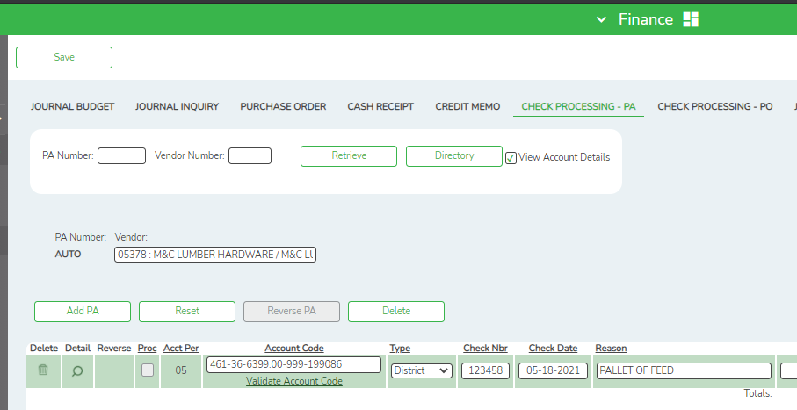

___ 9 In the Net Expend Amt field, type an amount for the check transaction.

___ 10 In the Invoice Date field, type the date of the invoice being paid by the transaction. The Invoice Date field is automatically filled using data from the previous row when the Net Expend Amt field is entered or modified on the selected row and the Invoice Date field on the selected row is empty.

___ 11 In the Invoice Nbr field, type the invoice number being paid by the transaction. The system verifies that the vendor and invoice number combination does not exist in the current or previous file ID. If the system finds the invoice number in a previous file ID, a warning message is displayed to continue using that invoice number or to enter a new number.
Note: The Invoice Nbr field is automatically filled using data from the previous row when the Net Expend Amt field is entered or modified on the selected row and the Invoice Nbr field on the selected row is empty.

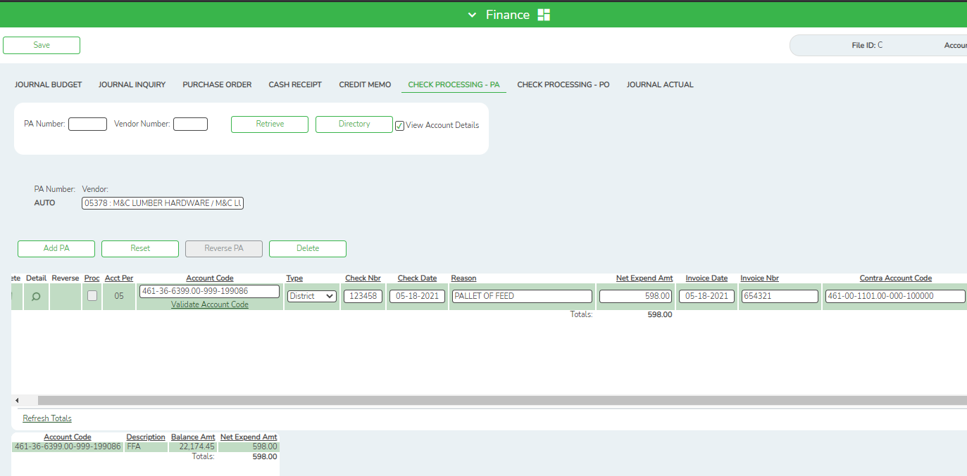

___ 12 In the Contra Account Code field, when a purchase authorization is created, the system automatically defaults to the payable object/subobject account in the District Finance Options > Clearing Fund Maintenance page with the same fund number and fiscal year as the account number that monies are being expended against. The user may modify the contra account for a district check (it cannot be modified for a computer check); however, the fund and fiscal year must be the same as the account number. The function code must be 00, and the object code must be 1XXX. Once the Contra Account field has been saved, it cannot be modified.

___ 13 In the Due Date field, the date represents the date that the check is to be processed. The field is automatically populated with the current system date if the district has selected "D - Use Due Date for Payables" on the District Options page. This field may be left blank if Use Due Date for Payables is not being utilized.

Note: If the user has selected "D - Use Due Date for Payables" for the Payables Date Used option on the District Options page, the system uses the date to determine whether it is time to print a check for the selected transaction. If the due date is within the range that the user listed on the Process Check page, or if the range is left blank, the check is printed. Otherwise, the transaction is retained until the due date is within the requested range. If the user changes the Payables Due Date option to "T - Use Transaction Date for Payables," the check is printed during the next check process.

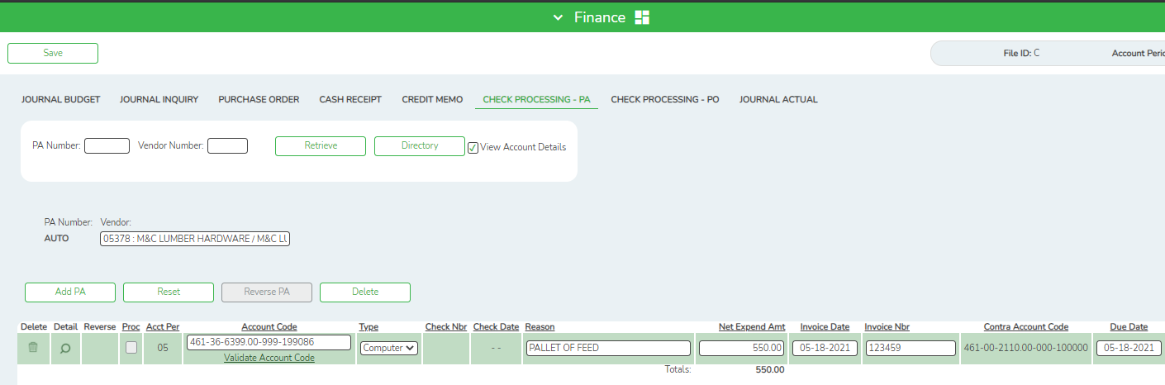

___ 14 Select EFT to disburse the payment via an electronic funds transfer. By default, the field is automatically selected if the retrieved vendor has bank information listed on the Maintenance > Vendor Information > Vendor Miscellaneous tab, and an EFT email address listed on the Maintenance > Vendor Information > Vendor Name/Address tab.
Note: The vendor must have bank information and an EFT email address on file to be eligible for an electronic funds transfer.

___ 15 The Print field is selected automatically when the transaction is created, and a check is printed, if the criteria for issuing the check (e.g., date or account balance) is met. The user can unselect the Print field, and the transaction is not processed when the checks are issued.

Note: If the field is not selected and end-of-month processing has occurred, the transaction is considered a deferred check transaction. When the user is ready to print the transaction, he must select Print. If date ranges are used as criteria for selecting checks for processing, the date of the transaction must be included in that selection criteria in order for it to be processed.
The user can verify all deferred checks by printing an Accounts Payable Listing (FIN1700). It is the only report in the system that prints both the due date and the entry dates. Other reports that would be helpful are the Expenditure and Liquidation Journal, the Capital Outlay Expenditure Report, the Check Register and Check Transaction Listing, and the Check Payment Listing.

___ 16 Select Separate Check if the user has a vendor that has multiple transactions and/or multiple payment authorization transactions and the user needs a separate check for one (or more) transaction. When Separate Check is selected, the associated transactions are displayed as separate check items in the list of checks to be processed. When checks are processed, those transactions with Separate Check selected will be issued separately. If selected, a credit memo will not be applied and the check amount will be for the full amount. Check transactions that do not have Separate Check selected are grouped by the vendor number.

Example: There are three separate PA transactions for the same vendor. The first PA has two transactions, one of which has Separate Check selected and the other does not. The second PA has a transaction that does not have Separate Check selected. The third PA has a transaction that also does not have Separate Check selected. When checks are processed, two checks are issued: one for the transaction that had Separate Check selected and one for all the other transactions for that vendor.

___ 17 The Trans Date field is set to the current system date. The user can modify the field.

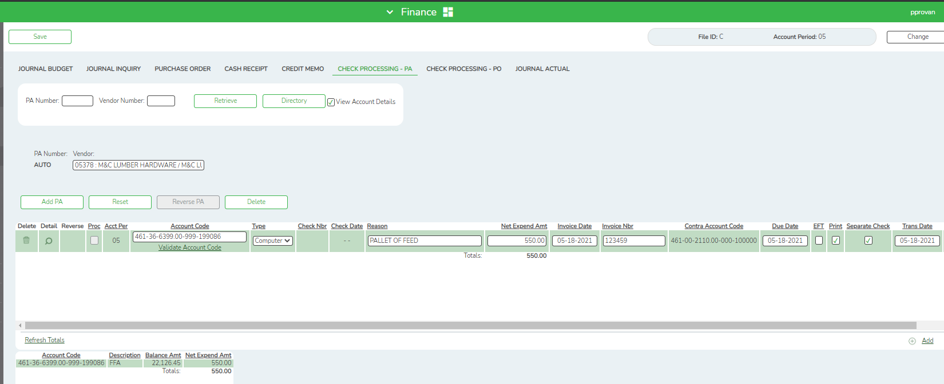

___ 18 To add another row, click +Add, or press ALT+1. Continue adding rows as needed.

___ 19 Click Save to save all transaction.

